**The Rise of E-commerce Nurseries and the Role of Fintech Digital Wallets**

**Introduction**

In recent years, the world of e-commerce has seen significant growth and transformation. One sector that has particularly benefited from this digital revolution is the nursery industry. With the convenience of online shopping and the emergence of fintech digital wallets, nursery businesses have found new ways to attract and engage customers. In this article, we will explore the rise of e-commerce nurseries and examine the pivotal role played by fintech digital wallets in revolutionizing the way consumers shop for nursery products.

**The Changing Landscape of E-commerce Nurseries**

1. The Shift to Online Shopping

Gone are the days when parents had to visit brick-and-mortar stores to purchase nursery essentials physically. The advent of e-commerce has provided a convenient and hassle-free alternative. Online nurseries offer a wide range of products, from cribs and strollers to bedding and toys, all at the click of a button. This shift to online shopping has revolutionized the nursery industry, making it easier for parents to find and purchase the products they need.

2. The Benefits of E-commerce Nurseries

The rise of e-commerce nurseries has brought numerous benefits to businesses and consumers. Online platforms provide businesses with a cost-effective way to reach a wider customer base. They can expand their market reach beyond local boundaries and cater to customers from all over the world. On the other hand, consumers enjoy the convenience of browsing through a vast selection of products, comparing prices, and making purchases from the comfort of their homes. E-commerce nurseries also offer doorstep delivery, saving parents valuable time and energy.

3. The Role of Fintech Digital Wallets

While e-commerce nurseries have made shopping more accessible, the introduction of fintech digital wallets has further enhanced the customer experience. Fintech digital wallets are mobile applications that allow users to store their payment information securely and make transactions with just a few taps on their smartphones. These digital wallets have become increasingly popular due to their convenience, security, and speed.

**The Benefits of Fintech Digital Wallets for E-commerce Nurseries**

1. Seamless and SecureTransactions

One of the primary benefits of fintech digital wallets for e-commerce nurseries is the ability to offer seamless and secure transactions. With digital wallets, customers no longer need to manually enter their payment details for each purchase. Instead, they can securely store their information within the wallet app and make payments with just a few clicks. This streamlines the checkout process, reducing friction and increasing conversion rates for nursery businesses.

2. Enhanced User Experience

Fintech digital wallets contribute to an enhanced user experience for customers. By eliminating the need to enter payment information repeatedly, digital wallets save users time and effort. Additionally, many digital wallets offer features such as loyalty programs, personalized recommendations, and easy access to order history. These features enhance customer engagement and loyalty, making the overall shopping experience more enjoyable.

3. Increased Security

Security is a top concern for both businesses and consumers in the online world. Fintech digital wallets address this concern by implementing robust security measures. They use encryption technology to protect sensitive payment information and often require additional authentication steps such as biometric verification or PIN codes. This added layer of security gives customers peace of mind when making transactions and helps build trust in e-commerce nurseries.

**Popular Fintech Digital Wallets for E-commerce Nurseries**

Apple Pay

Apple Pay is one of the most widely used digital wallets in the world. It allows users to make secure payments using their Apple devices, such as iPhones, iPads, and Apple Watches. With Apple Pay, customers can quickly complete purchases on e-commerce nursery websites or mobile apps by simply authenticating with their Touch ID or Face ID.

Google Pay

Google Pay, formerly known as Android Pay, is another popular digital wallet option. It is available on Android devices and offers similar features to Apple Pay. Customers can add their credit or debit cards to the Google Pay app and make fast and secure payments at e-commerce nurseries that support this payment method.

PayPal

PayPal is a well-established digital wallet that has been around for many years. It is widely accepted by e-commerce nurseries and offers a range of features, including buyer protection and the ability to link multiple payment methods. PayPal's reputation for security and reliability makes it a trusted choice for both businesses and consumers.

**The Future of E-commerce Nurseries and Fintech Digital Wallets**

The growth of e-commerce nurseries and fintech digital wallets shows no signs of slowing down. As technology continues to evolve, we can expect further innovations in this space. Here are some trends to watch out for:

Integration of Augmented Reality (AR)

Augmented reality (AR) is a technology that overlays virtual elements onto the real world. In the context of e-commerce nurseries, AR can allow customers to visualize how nursery products would look in their homes before making a purchase. By integrating AR capabilities into digital wallet apps, customers can use their smartphones to virtually place cribs, furniture, and other items in their nurseries, providing a more immersive and engaging shopping experience.

Voice-Activated Payments

With the rise of smart speakers and virtual assistants, voice-activated payments are becoming increasingly popular. In the future, customers may be able to make purchases from e-commerce nurseries using voice commands through their digital wallets. This hands-free and convenient method of payment could further enhance the user experience and simplify the shopping process.

Enhanced Personalization

Personalization is key to delivering a tailored shopping experience. In the future, fintech digital wallets may leverage artificial intelligence and machine learning algorithms to provide personalized product recommendations based on customers' browsing and purchase history. This level of personalization can help e-commerce nurseries showcase products that are relevant to each customer, increasing the likelihood of conversion.

**Conclusion**

The rise of e-commerce nurseries and the integration of fintech digital wallets have revolutionized the way parents shop for nursery products. The convenience, security, and enhanced user experience offered by digital wallets have made online shopping more accessible and enjoyable. As technology continues to advance, we can expect further innovations in this space, such as augmented reality integration and voice-activated payments. E-commerce nurseries and fintech digital wallets are shaping the future of the nursery industry, providing parents with a seamless and convenient shopping experience.

**Project Overview**

The nursery plants gardening eCommerce website will allow users to:

* Browse a catalog of plants and gardening products.
* Search for specific plants or products.
* View detailed product descriptions and images.
* Add items to a shopping cart.
* Proceed to checkout and make purchases securely.
* Receive email notifications for order updates and promotions.

**System Architecture**

The system architecture will follow a client-server model.

The client side will be built using Vite and React to provide a responsive and interactive user interface. The server side will handle business logic, authentication, and database interactions using Node.js and Express.js. MongoDB will be used as the primary database to store product information, user data, and order details. Mongoose will facilitate the interaction with MongoDB. Email notifications will be sent using the Gmail SMTP server. Payment processing will be integrated using a third-party payment gateway such as Stripe.

**Features**

* User Authentication: Allow users to register, log in, and manage their profiles.
* Product Catalog: Display a comprehensive catalog of plants and gardening products.
* Search Functionality: Enable users to search for specific items by name, category, or keywords.
* Shopping Cart: Allow users to add items to their cart, update quantities, and remove items.
* Checkout Process: Guide users through a secure checkout process with multiple payment options.
* Order Management: Provide users with order confirmation emails and access to their order history.
* Email Notifications: Send order updates, promotions, and other notifications to users via email.
* Payment Integration: Integrate with a third-party payment gateway (e.g., Stripe) for secure payment processing.

**Technology Stack**

* Frontend: React, JavaScript, HTML, CSS
* Backend: Node.js, Express.js
* Database: MongoDB
* Object Modeling: Mongoose
* Email Service: Gmail (SMTP)
* Payment Gateway Integration: Stripe API
* Deployment: Docker, Kubernetes (optional)

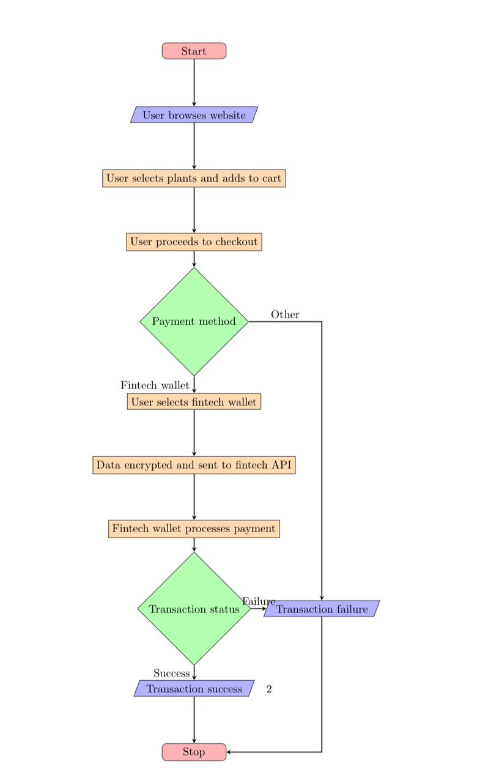

**Database Design**

The MongoDB database will consist of the following collections:

* Users: Stores user-profiles and authentication credentials.
* Products: Contains information about plants, gardening tools, and related products.
* Orders: Stores order details including products, quantities, and transaction information.

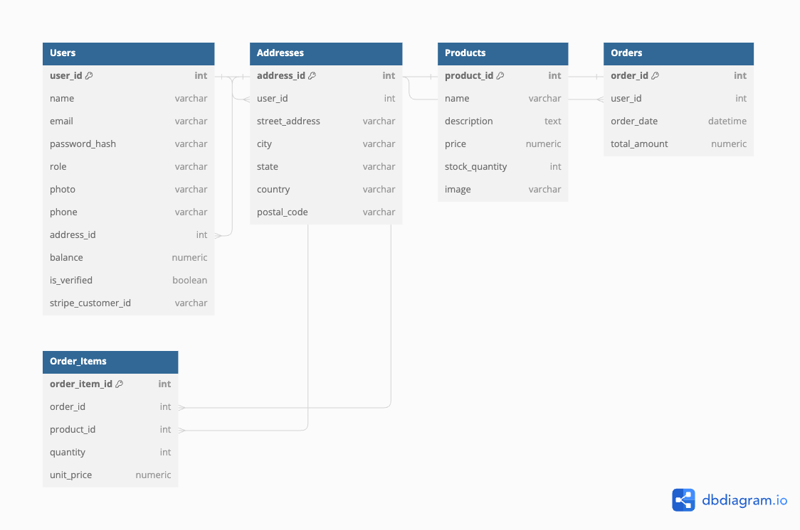**User Interface Design**

The user interface will be designed to be intuitive, visually appealing, and mobile-friendly. It will include:

* Home Page: Featuring featured products, promotions, and categories.
* Product Pages: Providing detailed information, images, and pricing for each product.
* Cart Page: Allowing users to review and modify their shopping cart before checkout.
* User Profile: Providing users with access to their order history, settings, and account information.

**Security**

User Authentication: Utilize authentication methods such as username/password, social login (OAuth), or biometric authentication (fingerprint, facial recognition) to verify user identities.

Secure Password Storage: Hash passwords using strong hashing algorithms like bcrypt before storing them in your database to prevent unauthorized access in case of a data breach.

JWT (JSON Web Tokens): Use JWT for session management and authentication tokens. Ensure tokens are securely stored on the client side (e.g., in HTTPOnly cookies) to prevent cross-site scripting (XSS) attacks.

**Deployment Strategy**

1. Develop the website using a frontend framework like React.
2. Set up a Vercel account and link your repository for seamless deployment.
3. Utilize Vercel's built-in features for easy scaling and performance optimization.